Odd Numbers
# Source: AI Source: Provided by: [Data Path: Persons Table -> ID Column: 1, Name_En Column: Motasem Essam] -> From: [ChatGPT] on [7/13/2026]
Odd numbers are integers that are not divisible by 2, leaving a remainder of 1 when divided by 2. They form one of the two categories of integers based on parity, the other being even numbers.
Odd numbers are fundamental in arithmetic, elementary number theory, algebra, computer science, and many other areas of mathematics.

Definition
# Source: AI Source: Provided by: [Data Path: Persons Table -> ID Column: 1, Name_En Column: Motasem Essam] -> From: [ChatGPT] on [7/13/2026]
An odd number is an integer that is not divisible by
$$2.$$
Mathematically, an integer
$$n$$
is odd if there exists an integer
$$k$$
such that
$$n=2k+1.$$
An equivalent form is
$$n=2k-1.$$
Equivalently,
$$n≡1(mod2)$$
or
$$n≡-1(mod2).$$
where:
- $n$is the given integer.
- $k$is an integer.

Rules for Odd Numbers

1. An Odd Number Is Not Divisible by Two
# Source: AI Source: Provided by: [Data Path: Persons Table -> ID Column: 1, Name_En Column: Motasem Essam] -> From: [ChatGPT] on [7/13/2026]
Every odd number cannot be divided evenly by
$$2.$$
It leaves a remainder of
$$1.$$
Example
$$17÷2=8$$
remainder
$$1.$$

2. An Odd Number Has the Form $2k+1$
# Source: AI Source: Provided by: [Data Path: Persons Table -> ID Column: 1, Name_En Column: Motasem Essam] -> From: [ChatGPT] on [7/13/2026]
Every odd integer can be written as
$$2k+1$$
for some integer
$$k.$$
Example
$$25=2×12+1.$$

3. An Odd Number May Be Positive or Negative
# Source: AI Source: Provided by: [Data Path: Persons Table -> ID Column: 1, Name_En Column: Motasem Essam] -> From: [ChatGPT] on [7/13/2026]
Odd numbers include both positive and negative integers.
Example
$$-11=2×(-6)+1.$$
Therefore,
$$-11$$
is odd.

4. Consecutive Odd Numbers Differ by Two
# Source: AI Source: Provided by: [Data Path: Persons Table -> ID Column: 1, Name_En Column: Motasem Essam] -> From: [ChatGPT] on [7/13/2026]
The difference between consecutive odd numbers is always
$$2.$$
Example
$$9, 11, 13, 15.$$

5. Every Prime Greater Than Two Is Odd
# Source: AI Source: Provided by: [Data Path: Persons Table -> ID Column: 1, Name_En Column: Motasem Essam] -> From: [ChatGPT] on [7/13/2026]
Since every even number greater than
$$2$$
is divisible by
$$2,$$
every prime number greater than
$$2$$
must be odd.
Example
$$3, 5, 7, 11, 13.$$

6. Not Every Odd Number Is Prime
# Source: AI Source: Provided by: [Data Path: Persons Table -> ID Column: 1, Name_En Column: Motasem Essam] -> From: [ChatGPT] on [7/13/2026]
Many odd numbers are composite.
Example
$$27=3×9.$$
Therefore,
$$27$$
is odd but not prime.

7. Odd Numbers Alternate with Even Numbers
# Source: AI Source: Provided by: [Data Path: Persons Table -> ID Column: 1, Name_En Column: Motasem Essam] -> From: [ChatGPT] on [7/13/2026]
Every odd number is immediately preceded and followed by an even number.
Example
$$18, 19, 20.$$
Here,
$$19$$
is odd.

Examples
# Source: AI Source: Provided by: [Data Path: Persons Table -> ID Column: 1, Name_En Column: Motasem Essam] -> From: [ChatGPT] on [7/13/2026]
Example 1
Determine whether
$$7$$
is odd.
Since
$$7=2×3+1,$$
it is odd.

Example 2
Determine whether
$$-19$$
is odd.
Since
$$-19=2×(-10)+1,$$
it is odd.

Example 3
Determine whether
$$42$$
is odd.
Since
$$42$$
is divisible by
$$2,$$
it is not odd.

Example 4
Determine whether
$$101$$
is odd.
Since
$$101=2×50+1,$$
it is odd.

Example 5
List the odd numbers from
$$1$$
to
$$15. \\ 1, 3, 5, 7, 9, 11, 13, 15.$$

Example 6
Determine whether
$$0$$
is odd.
Since
$$0$$
is divisible by
$$2,$$
it is not odd.

Properties of Odd Numbers
# Source: AI Source: Provided by: [Data Path: Persons Table -> ID Column: 1, Name_En Column: Motasem Essam] -> From: [ChatGPT] on [7/13/2026]
- Not divisible by
$$2.$$
- Have the form
$$2k+1$$
(or equivalently
$$2k-1$$
).
- Leave a remainder of
$$1$$
when divided by
$$2.$$
- Can be positive or negative.
- Consecutive odd numbers differ by
$$2.$$

Arithmetic Properties of Odd Numbers
# Source: AI Source: Provided by: [Data Path: Persons Table -> ID Column: 1, Name_En Column: Motasem Essam] -> From: [ChatGPT] on [7/13/2026]
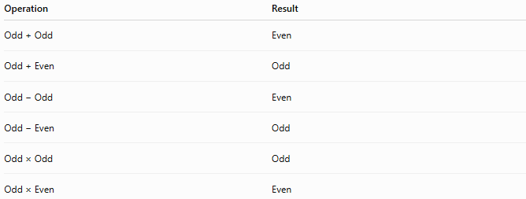
Operation | Result
Odd + Odd | Even
Odd + Even | Odd
Odd − Odd | Even
Odd − Even | Odd
Odd × Odd | Odd
Odd × Even | Even

Real-Life Applications
# Source: AI Source: Provided by: [Data Path: Persons Table -> ID Column: 1, Name_En Column: Motasem Essam] -> From: [ChatGPT] on [7/13/2026]
Odd numbers are used in:
- Computer science
- Cryptography
- Algorithm design
- Digital communication
- Engineering
- Mathematics education
- Number theory
- Scheduling
- Data organization
- Discrete mathematics

Real-Life Examples
# Source: AI Source: Provided by: [Data Path: Persons Table -> ID Column: 1, Name_En Column: Motasem Essam] -> From: [ChatGPT] on [7/13/2026]
1. Classroom Pairing
If there are
$$25$$
students, one student will remain when everyone is paired.

2. Sports Tournaments
A competition with an odd number of players often requires one player to receive a bye.

3. Computer Programming
Programs frequently determine whether a number is odd before applying specific algorithms.

4. Cryptography
Large odd numbers are commonly tested for primality when generating encryption keys.

5. Mathematics Education
Students use odd numbers to study parity, divisibility, and prime numbers.

6. Digital Systems
Some communication systems use odd parity bits for error detection.

Common Mistakes
# Source: AI Source: Provided by: [Data Path: Persons Table -> ID Column: 1, Name_En Column: Motasem Essam] -> From: [ChatGPT] on [7/13/2026]
- Thinking every odd number is prime.
- Forgetting that negative integers can be odd.
- Believing that zero is odd.
- Confusing odd numbers with odd prime numbers.
- Assuming every number ending in an odd digit is prime.

Key Points
# Source: AI Source: Provided by: [Data Path: Persons Table -> ID Column: 1, Name_En Column: Motasem Essam] -> From: [ChatGPT] on [7/13/2026]
- An odd number is not divisible by
$$2.$$
- Every odd integer has the form
$$2k+1.$$
- Odd numbers may be positive or negative.
- Every prime greater than
$$2$$
is odd.
- Not every odd number is prime.
- Consecutive odd numbers differ by
$$2.$$

Even Numbers vs. Odd Numbers
# Source: AI Source: Provided by: [Data Path: Persons Table -> ID Column: 1, Name_En Column: Motasem Essam] -> From: [ChatGPT] on [7/13/2026]
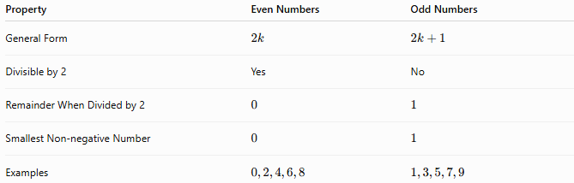
Property | Even Numbers | Odd Numbers
General Form | $$2k$$ | $$2k+1$$
Divisible by 2 | Yes | No
Remainder When Divided by 2 | $$0$$ | $$1$$
Smallest Non-negative Number | $$0$$ | $$1$$
Examples | $$0,2,4,6,8$$ | $$1,3,5,7,9$$

Conclusion
# Source: AI Source: Provided by: [Data Path: Persons Table -> ID Column: 1, Name_En Column: Motasem Essam] -> From: [ChatGPT] on [7/13/2026]
Odd numbers are integers that are not divisible by 2, meaning they can be written in the form $2k+1$for some integer $k$. They include both positive and negative integers and are one of the two fundamental parity classes of integers. Odd numbers are essential in arithmetic, elementary number theory, algebra, computer science, cryptography, and many practical applications involving divisibility, algorithms, and mathematical reasoning.

